Title written short and concise: Capital, 14 pt, times new roman, centered, bold, maximum 20 words

Author Full Name,^{1*} Author Full Name²

¹Faculty, Institution, Country, email: author1@email.ac.id
²Faculty, Institution, Country, email: author2@email.ac.id
*Corresponding author: author1@email.ac.id

Abstract
Purpose ‒ The abstract is limited to 150-250 words, in Times New Roman 12 pt, single-spaced, and justified (aligned both left and right). State the research objective, problem, and significance.
Design/Methodology/Approach ‒ Describe the research design, methodology, and approach used. Include details about data collection methods, sample size, and analysis techniques.
Findings ‒ Summarize the key results or outcomes of the study. Highlight any significant patterns, relationships, or trends observed
Originality/Value ‒ Explain the unique contribution of the study to existing knowledge. Discuss how the research fills gaps in the literature or offers new insights.
Research Limitations/Implications ‒ Acknowledge any limitations of the study (e.g., sample size, scope, methodology). Discuss theoretical or practical implications arising from the findings.
Practical Implications ‒ Describe how the research can be applied in real-world settings. Highlight actionable recommendations for practitioners or policymakers.

Keywords ‒ Maximum of Seven Words/Phrases, Capitalize Each Word. Separate Keywords with Commas

- Introduction (14 pt, times new roman, bold)
The text should be formatted in 12-point Times New Roman, normal, and set with single-line spacing. Present the research background, state of the art (the current state of knowledge, key findings, and recent developments in the field based on relevant previous studies), research gap, research objectives, and the study’s novelty and contributions to academic and/or practical knowledge.
- Literature review (14 pt, times new roman, bold)
The text should be formatted in 12-point Times New Roman, normal, and set with single-line spacing. Critically review relevant theories and previous studies to establish the theoretical foundation, identify unresolved issues, and develop the conceptual framework and hypotheses, where applicable.
2.1. Subheading 1 (12 pt, times new roman, italic)
Discuss relevant concepts and prior findings critically, highlighting their relationships to the research problem and objectives.
This section discusses relevant theories and prior research that provide the theoretical foundation for the study. It should include a conceptual framework and hypothesis development where applicable.
2.1.1. Sub-subheading (12 pt, times new roman)
Use this level only when necessary to organize specific concepts, arguments, or theoretical relationships.
- Methodology
Use 12-point Times New Roman, normal, with single-line spacing. Describe the research design, data sources, population and sampling or participant selection, data collection procedures, research instruments, and data analysis methods. Define variables and explain the research model where applicable.
Ensure methodological transparency, justify the suitability of the methods for the research objectives, and report relevant validity, reliability, or trustworthiness procedures.
- Results
Use 12-point Times New Roman, normal, with single-line spacing. Present the main research findings clearly and objectively, addressing the research questions or hypotheses. Report relevant data analysis results and support key findings with appropriately numbered tables and figures, where applicable.
Avoid repeating the same information in the text, tables, and figures.

- Discussion
Use 12-point Times New Roman, normal, with single-line spacing. Interpret the main findings in relation to the research objectives, relevant theories, and previous studies. Explain how the findings confirm, extend, or challenge existing knowledge, and highlight the study’s theoretical and/or practical contributions.
Support interpretations with evidence and avoid merely repeating the results.
- Conclusions and future research
Use 12-point Times New Roman, normal, with single-line spacing. Summarize the main findings and explain how they address the research objectives. Highlight the study’s key contributions and practical implications, acknowledge relevant limitations, and provide specific recommendations for future research. Ensure that all conclusions are supported by the findings and avoid introducing new results or arguments.

Table and Figure
Table
Tables should be left-aligned. Ensure tables are created using the "Insert Table" function. Every table must be referenced in the text (e.g., see Table 1).
Table 1. Using sentence case (First Letter Capital)
No |  | Column Header | Column Header | Numeric
1 | Table content. If space is limited, font size may be reduced to a minimum of 10 pt. |  | Regular font | Align Center  0.010
Source: Processed Data (Year) (or other source)
Table titles are placed above the table in bold and sentence case, without ending with a period. Tables should not be split across pages unless necessary; if a table spans multiple pages, the header row must be repeated, the same table number retained. Additionally, vertical lines should not be used in table.

Figure
Like tables, every figure must have a sequential number and a title. Figures should appear professional and should not include borders. Use color when it improves clarity and accessibility; ensure that figures remain interpretable when printed in grayscale.

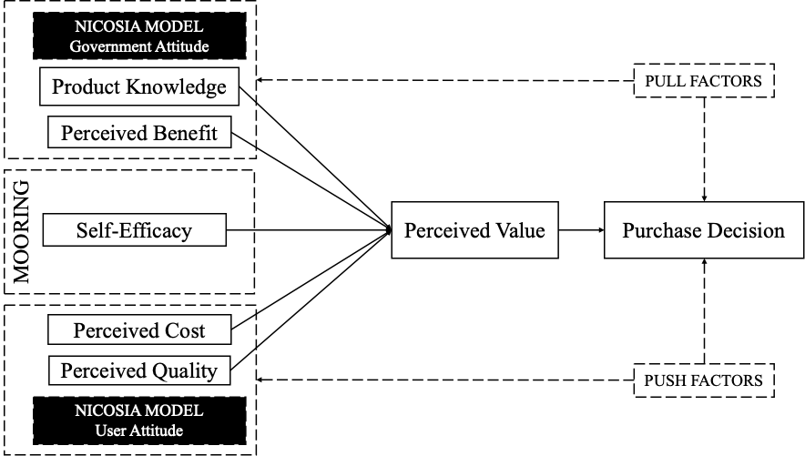
Source: Processed data (year) (or other source)
Figure 1. Title of figure, using sentence case (First letter capital)

Acknowledgement ‒ The authors may acknowledge individuals or organizations that provided assistance during the research or manuscript preparation but do not qualify for authorship. This section should also disclose whether the manuscript is based on previous academic work, such as a conference paper, thesis, or dissertation, and identify any relevant funding or grant support. Any previous version must be disclosed to the journal, and the manuscript must comply with the journal’s originality and publication ethics requirements.
Author Contributions ‒ Specify each author's contribution using their initials and the applicable CRediT roles: Conceptualization, Methodology, Software, Data Curation, Formal Analysis, Investigation, Resources, Validation, Visualization, Writing—Original Draft, Writing—Review & Editing, Funding Acquisition, Project Administration, and Supervision. Include only roles that accurately reflect each author's actual contributions. All authors must approve the final manuscript.
Funding Statement ‒ Please disclose all financial support received for conducting the research or preparing the manuscript. Include the name of the funding agency or institution and the grant number, if applicable. If the research received no specific funding, state this explicitly.
Conflict of Interest ‒ Please disclose any financial, professional, personal, or other relationships that could reasonably be perceived as influencing the research or its interpretation. If no competing interests exist, include the statement below. Example (no conflict of interest): The authors declare no conflict of interest.
Ethical Approval / Informed Consent ‒ For research involving human participants, personal data, or other activities requiring ethical review, please identify the approving ethics committee or institutional review board, the approval number, and the date of approval, where applicable. State whether informed consent was obtained from participants. If ethical approval or informed consent was not required, explain the reason briefly. Authors must ensure that their research complies with applicable ethical standards and legal requirements.
Data Availability Statement ‒ The authors should submit a brief summary of the data used in the paper to the journal. In case of any query/request from readers, this will be made available. Write none is there is no data to be shared
AI Use Declaration ‒ Please disclose the use of generative artificial intelligence (AI) tools in preparing the manuscript or conducting the research, in accordance with the journal’s AI policy. Identify the tool and describe its purpose and scope of use. Authors remain fully responsible for the accuracy, originality, integrity, and final content of the manuscript. AI tools must not be listed as authors.
Appendix
If any
References
References must be prepared using Mendeley with the American Psychological Association (APA) 7th Edition style, or follow the guidelines below:
Nuh, A., Rizan, M., & Sadat, A. M. (2025). Exploring continued use intention of the AI platform among students in Indonesia: An extended ECM framework. Interdisciplinary Journal of Information, Knowledge, and Management, 20, 006.
1. Book:
Author(s) (Last name, Initials). (Year). Title of book in italics (Edition). Publisher. Place of publication.
Example:
Nuh, A., Rizan, M., & Sadat, A. M. (2025). Exploring continued use intention of the AI platform among students in Indonesia: An extended ECM framework. Interdisciplinary Journal of Information (3rd ed.). Informing Publishing, USA.
2. Journal article:
Author(s) (Last name, Initials). (Year). Title of article. Name of Journal in Italics, Volume (Issue), Page range.
Example:
Nuh, A., Rizan, M., & Sadat, A. M. (2025). Exploring continued use intention of the AI platform among students in Indonesia: An extended ECM framework, Knowledge, and Management, 20, 006.
3. Conference/proceedings paper:
Author(s) (Last name, Initials). (Year). Title of paper. In Name of Conference. Date Month Year, City, Country (pp. Page range).
Example:
Nuh, A., Rizan, M., & Sadat, A. M. (2025). Exploring continued use intention of the AI platform among students in Indonesia: An extended ECM framework. In Proceedings of the Marketing International Conference on California (pp. 776–786). February 16–18, 2025, USA.
4. Thesis or dissertation:
Author (Last name, Initials). (Year). Title of thesis or dissertation (Unpublished master’s thesis or doctoral dissertation). University.
Example:
Nuh, A., Rizan, M., & Sadat, A. M. (2025). Exploring continued use intention of the AI platform among students in Indonesia: An extended ECM framework. (Unpublished disertasion). Faculty of Economics, State university of Jakarta.
5. Website/online source:
Author(s). (Year). Title of webpage. URL. Accessed Month Day, Year.
Example:
Nuh, A., Rizan, M., & Sadat, A. M. (2025). Exploring continued use intention of the AI platform among students in Indonesia: An extended ECM framework. https://www.ijikm.org/Volume20/IJIKMv20Art006Nuh11062.pdf. Accessed August 12, 2018.

About the authors
After the manuscript is accepted, each author must provide a brief biography (3–4 lines) describing their academic affiliation, research interests, and relevant academic or professional background. The corresponding author's email address must also be provided for publication.

